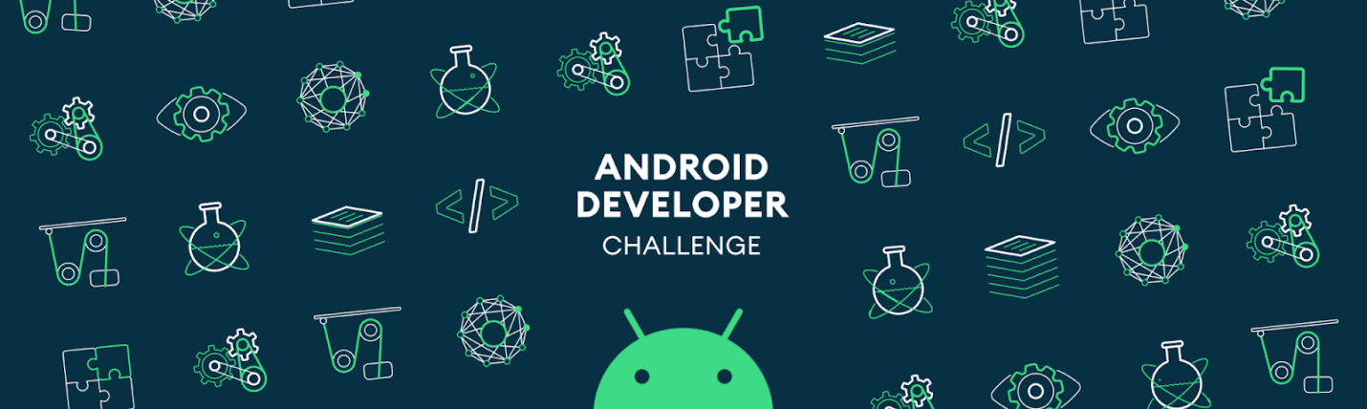

**Tell us what your idea is.**

*Real problem of blinds is that, they can't see and click on any view in our android system then how they going to use your APP. So basic requirement for blinds is an IVR-OS which will help them to save people in their contact list, search things with voice reorganization, find recognize people/objects with camera (which can be a small spy cam, always connected to their shirt/top or something similar as it will help user not to hold the phone every time).*

*Surely this OS requires very basic common sense rules to take user to particular app or utility. For example, If I want to open a calculator then I would be saying "OS open calculator".*

*This OS can be evolve gradually in multiple languages.*

*The one of the main features of this OS is IVR which will be AI system using NLP libraries to interact with user.*

*All applications in this OS will be voice specific so user can easily connect to it. For example, Searching something on Google and listening the results, listening the books, music, calling someone, saving someone in contact list/calendar, voice based games, voice chatting app, checking weather, checking/writing/sending emails, checking banking apps with voice reorganization (as password) only, calling a taxi, etc.*

*Machine learning is very much required in this OS to understand user, and his regular life requests for example in face reorganization, voice reorganization, and in many other applications.*

**Tell us how you plan on bringing it to life.**

*This is an Idea as of now and haven’t implemented as of now.*

**Tell us about you.**

I am a Developer and developing applications using NLP and other AI libraries since 2008.